- HOME WiFi NETWORK USING CISCO PACKET TRACER ASSIGNMENT (REVIEW PRATICAL)

Q1. Create the HomeWiFiNetwork Packet Tracer Project
Objective: Create a simple home network containing three PCs and one wireless router in Cisco Packet Tracer.
Step 1: Open Cisco Packet Tracer and create a new blank project.
Step 2: From Network Devices, select Wireless Devices and place one wireless router in the workspace. A common choice is the WRT300N wireless router.
Step 3: From End Devices, drag three PCs (PC-PT) into the workspace and arrange them around the router.
Step 4: Connect each PC to the wireless router using Copper Straight-Through cables. Connect each PC's FastEthernet0 port to one of the router's LAN Ethernet ports (1, 2, and 3).
Step 5: Wait until the link indicators become green.
Step 6: Go to File > Save As, enter HomeWiFiNetwork.pkt, choose the required folder, and click Save.
Suggested topology: PC0 -> Router LAN 1, PC1 -> Router LAN 2, PC2 -> Router LAN 3.
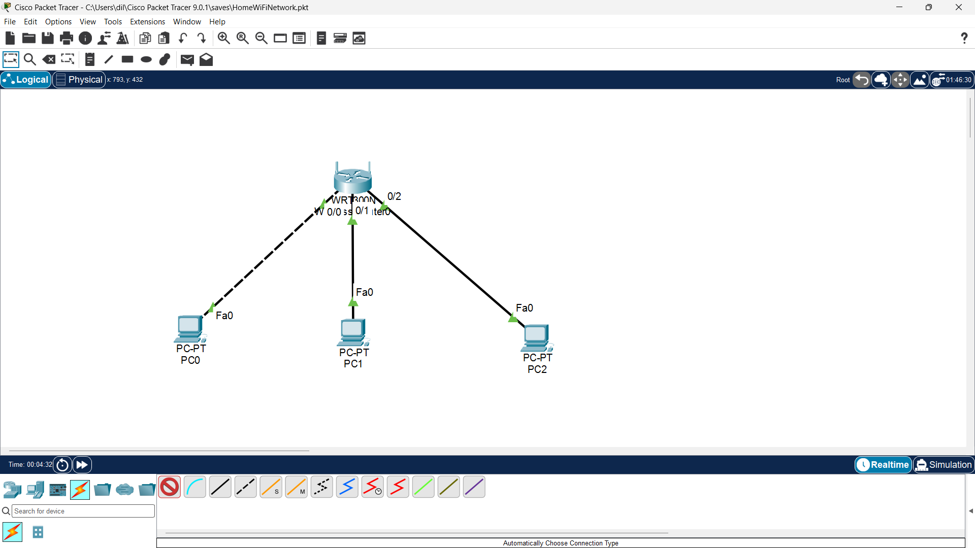

Q2. Assign Static IP Addresses to the PCs
Objective: Place all PCs on the same IPv4 subnet and use the wireless router as their default gateway.
Use the following example addressing scheme:
Device | IP Address | Subnet Mask | Default Gateway
Wireless Router (LAN) | 192.168.10.1 | 255.255.255.0 | -
PC0 | 192.168.10.2 | 255.255.255.0 | 192.168.10.1
PC1 | 192.168.10.3 | 255.255.255.0 | 192.168.10.1
PC2 | 192.168.10.4 | 255.255.255.0 | 192.168.10.1

Step 1: Open the wireless router and configure its LAN/local IP address as 192.168.10.1 with subnet mask 255.255.255.0. If DHCP is enabled, make sure it does not conflict with the static addresses below.
Step 2: Click PC0 > Desktop > IP Configuration. Select Static and enter 192.168.10.2, subnet mask 255.255.255.0, and gateway 192.168.10.1.
Step 3: Click PC1 > Desktop > IP Configuration. Select Static and enter 192.168.10.3, subnet mask 255.255.255.0, and gateway 192.168.10.1.
Step 4: Click PC2 > Desktop > IP Configuration. Select Static and enter 192.168.10.4, subnet mask 255.255.255.0, and gateway 192.168.10.1.
Step 5: Close each configuration window after checking that the values are correct.
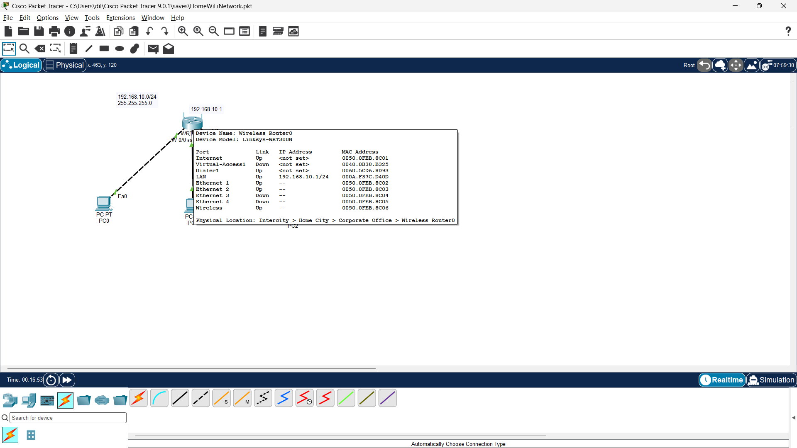
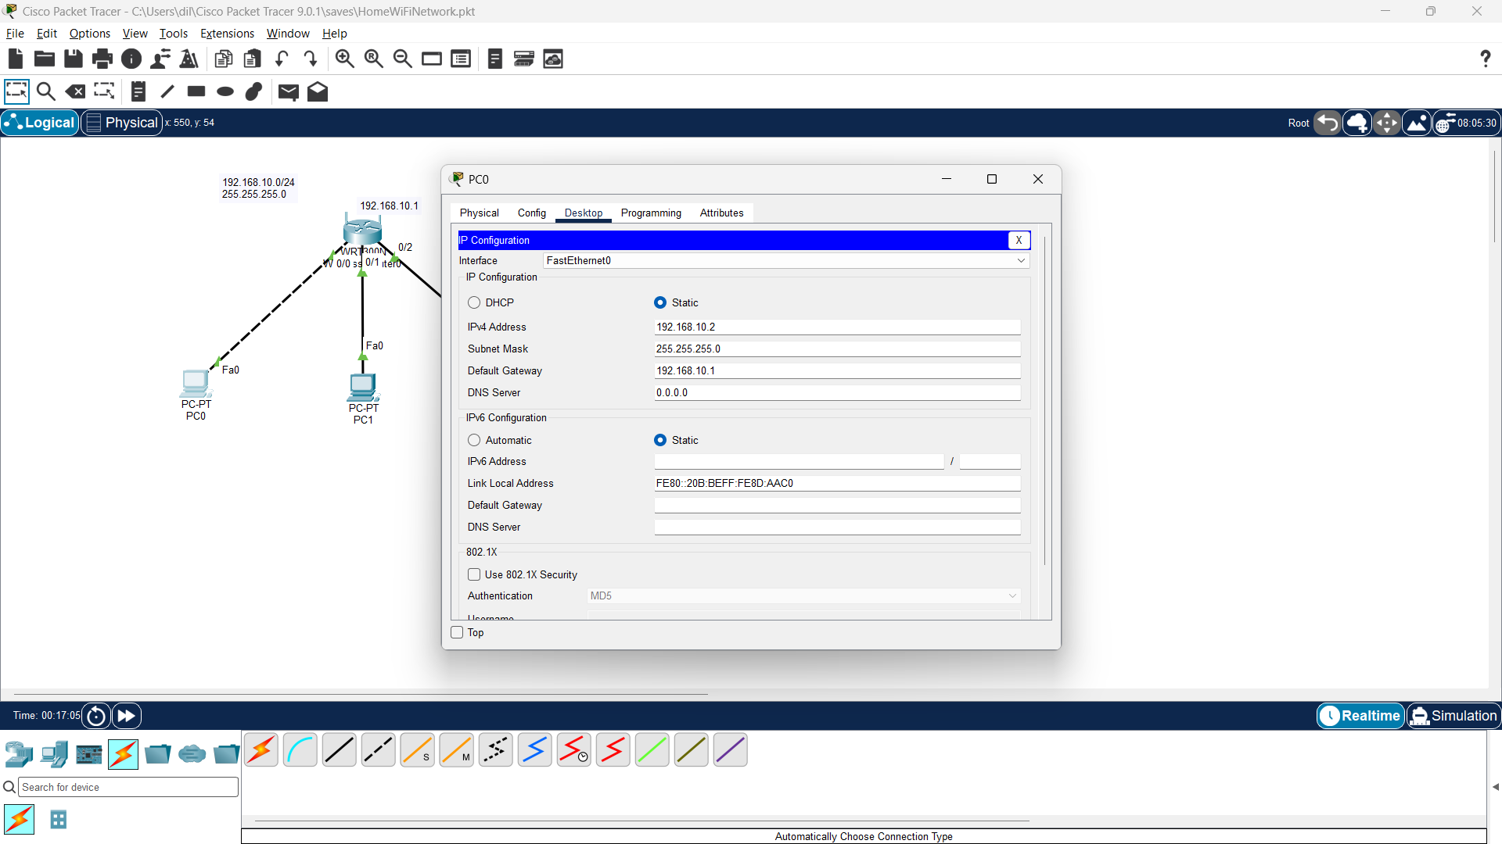
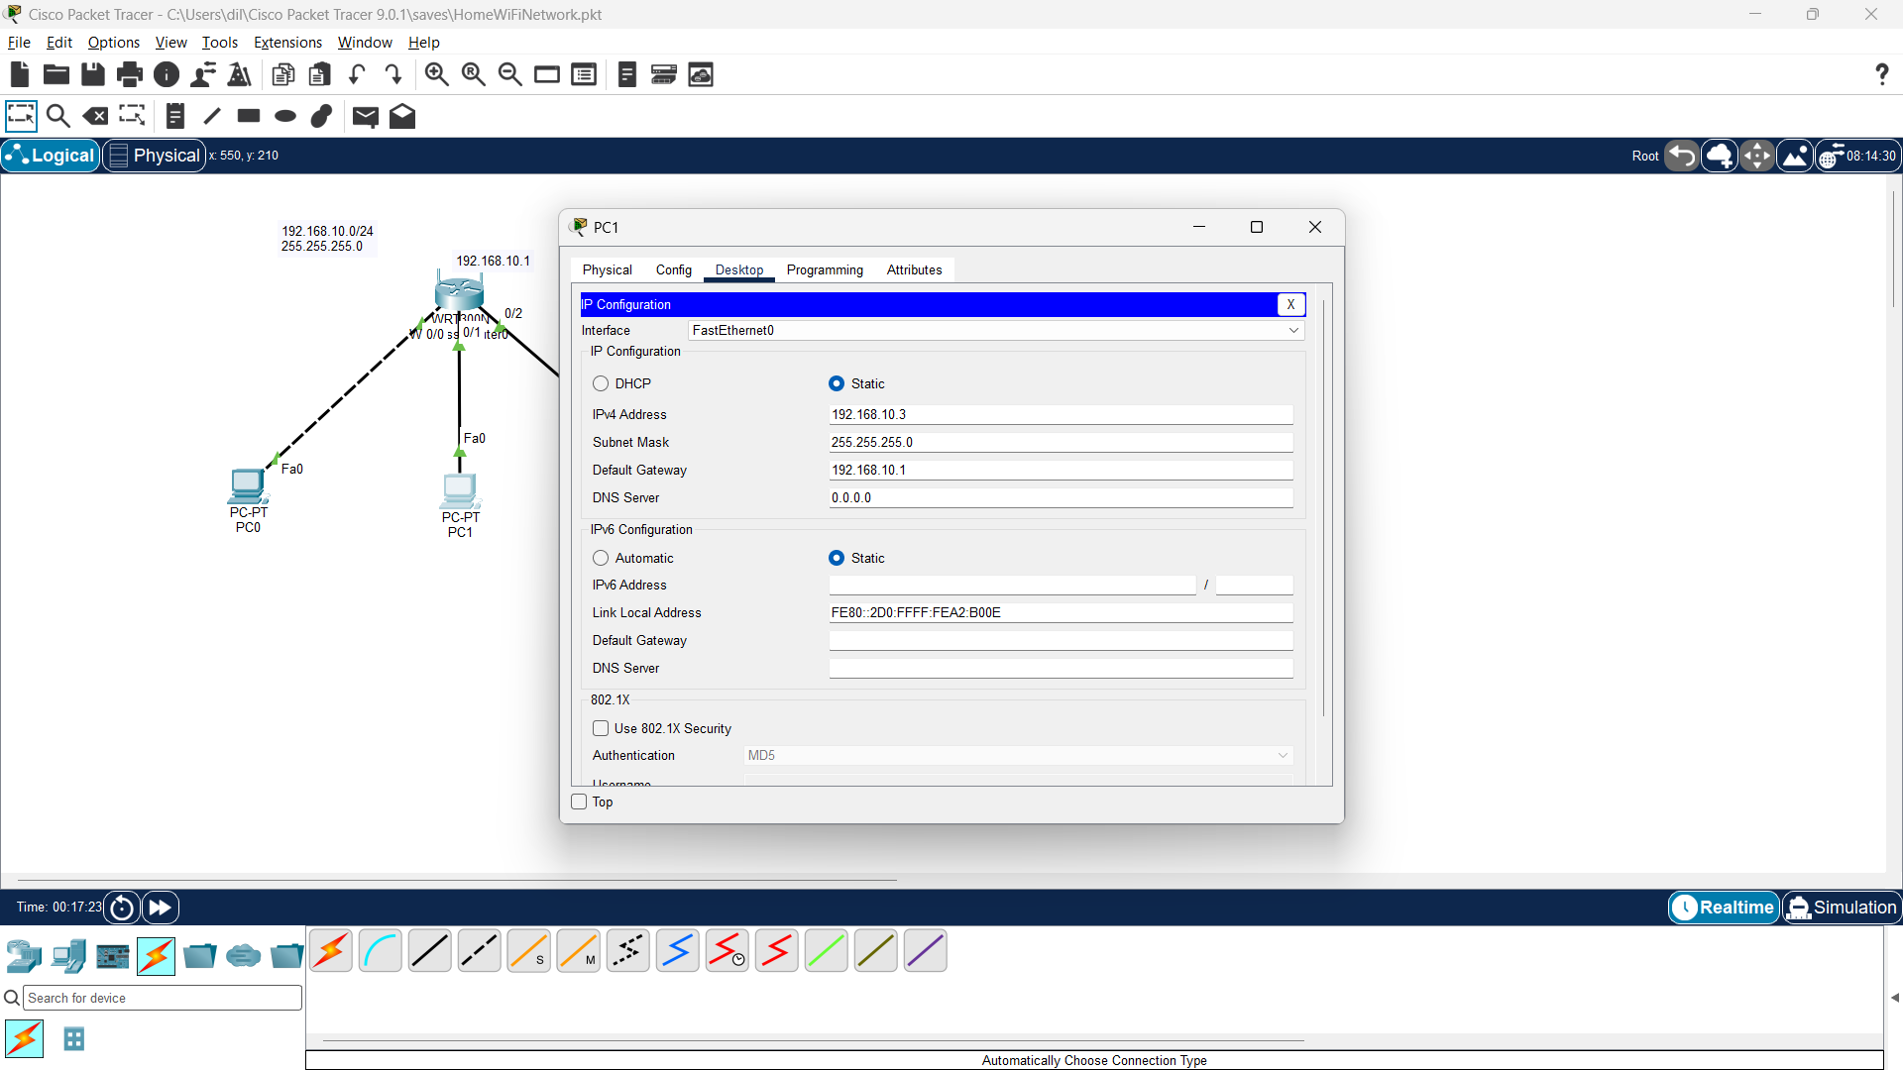
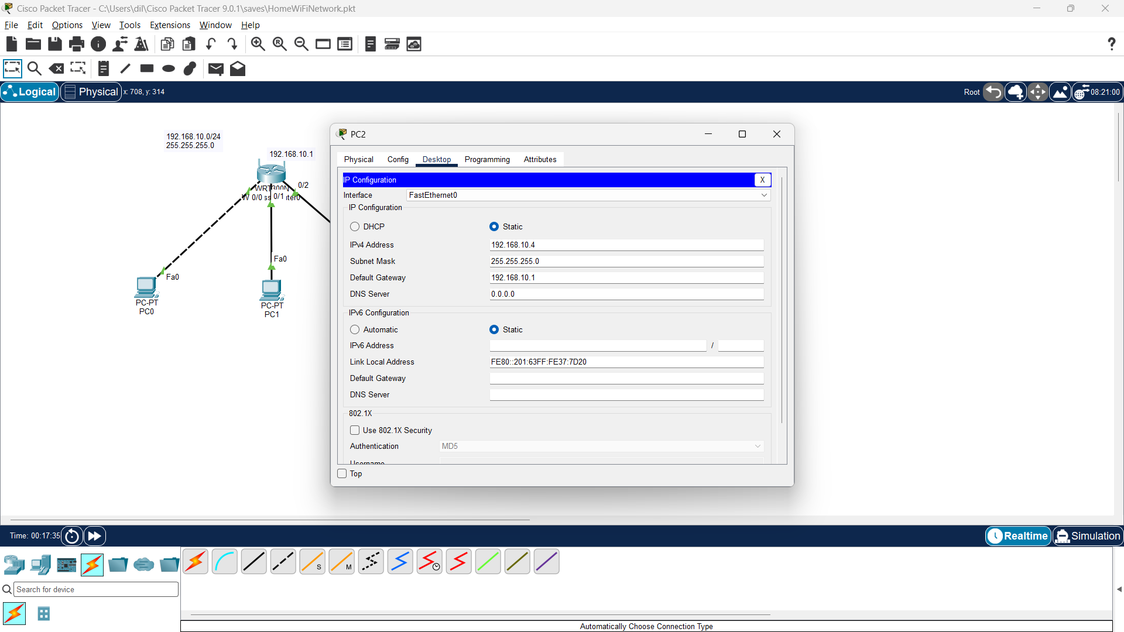

Q3. Test Connectivity Using Ping
Objective: Verify that all PCs can communicate with one another and with the router.
Step 1: Click PC0 > Desktop > Command Prompt.
Step 2: Ping the router by typing: ping 192.168.10.1
Step 3: From PC0, ping PC1: ping 192.168.10.3
Step 4: From PC0, ping PC2: ping 192.168.10.4
Step 5: Open Command Prompt on PC1 and PC2 and repeat ping tests to the other PCs.
Step 6: A successful test should show Reply from messages. If a ping fails, check the IP address, subnet mask, gateway, and cable/link status.
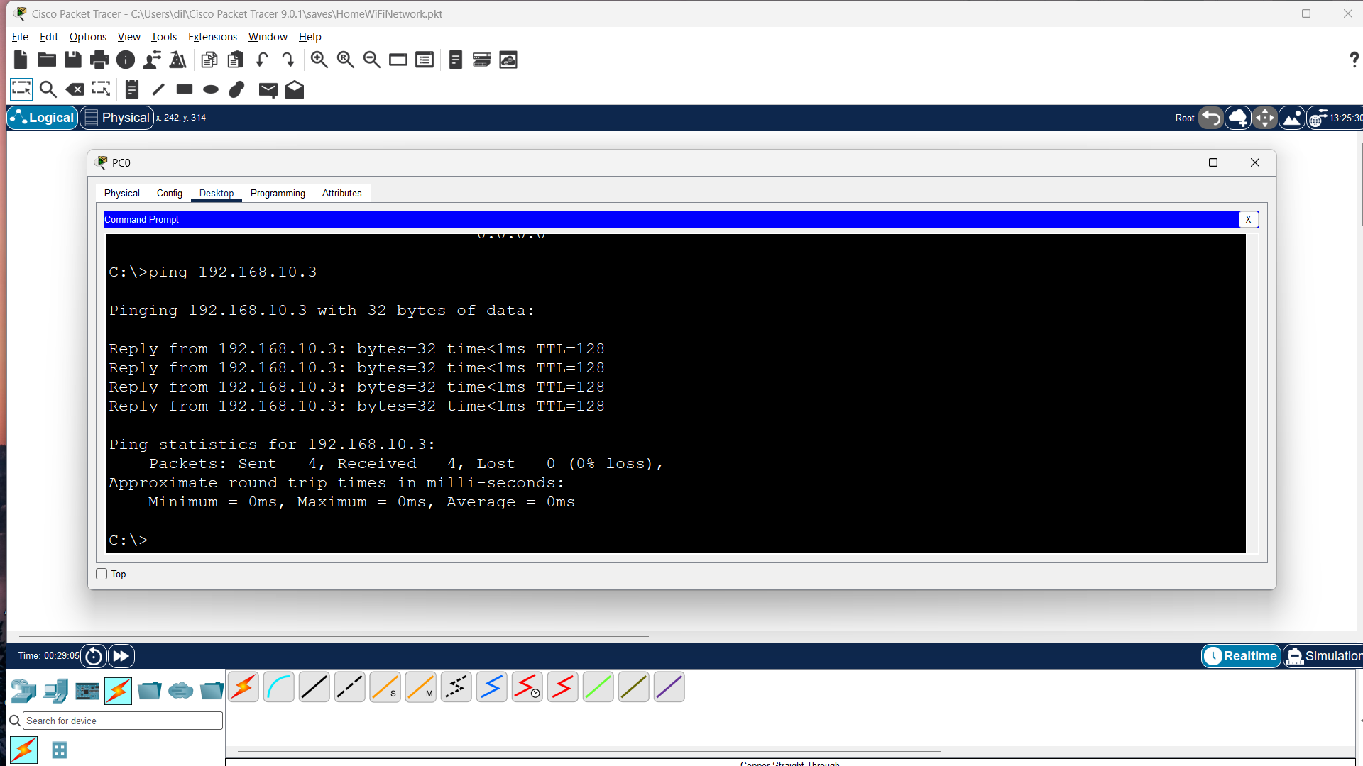
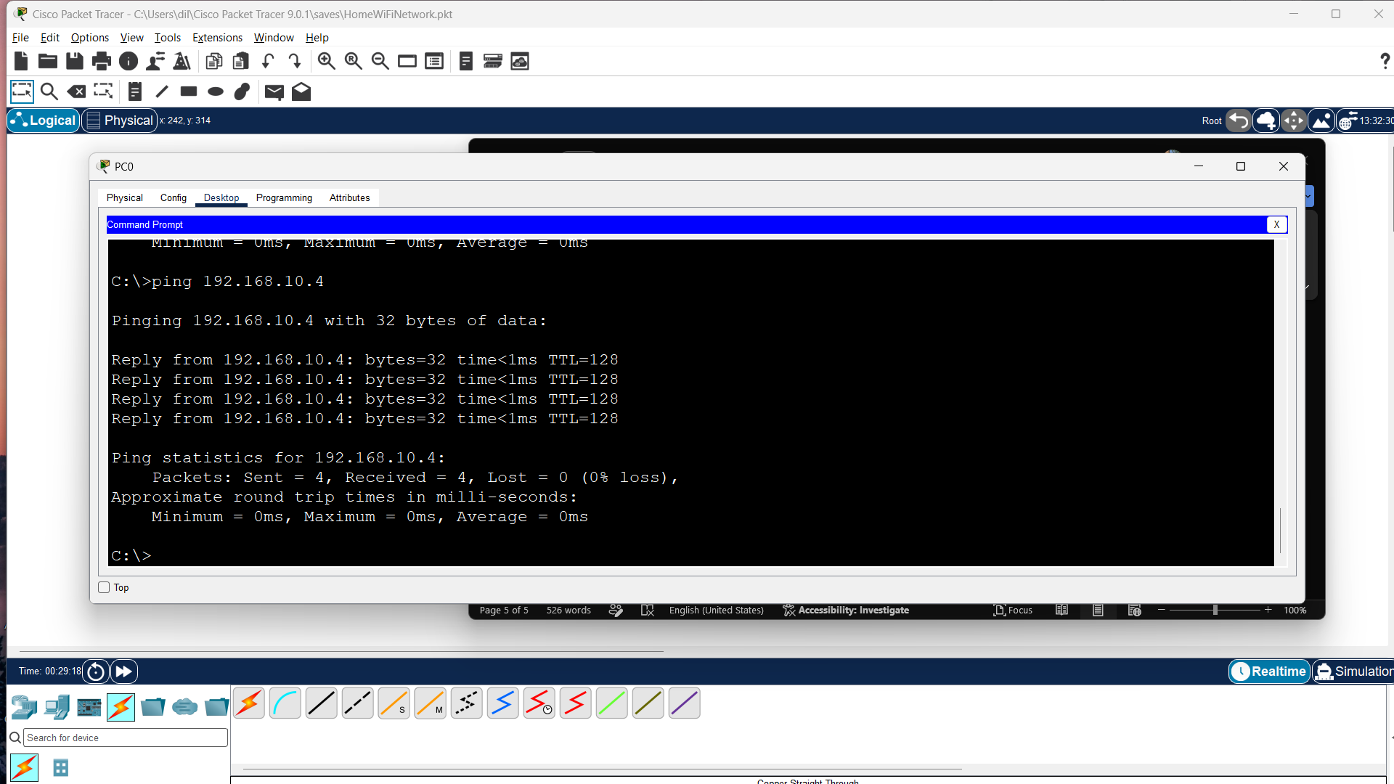
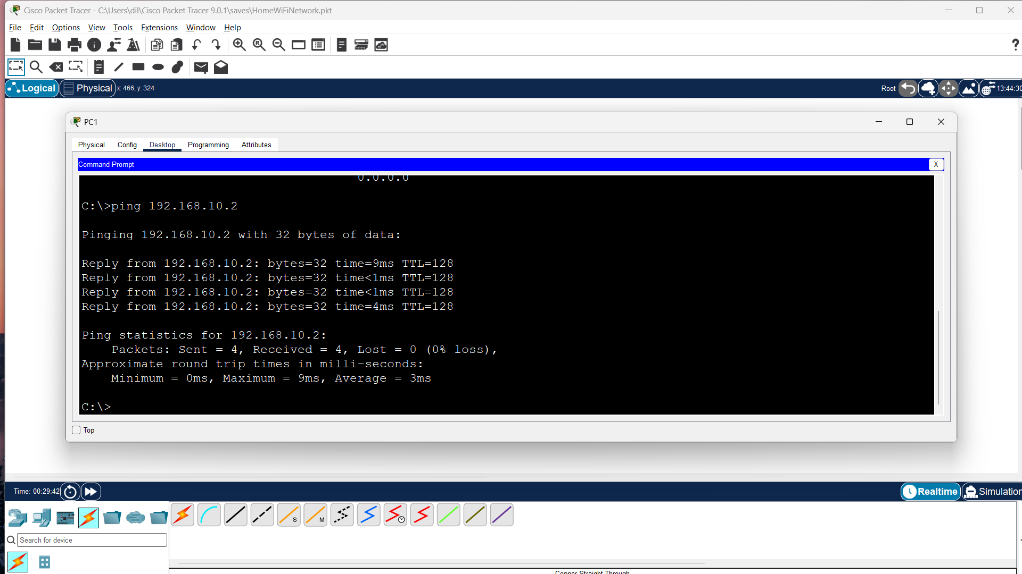
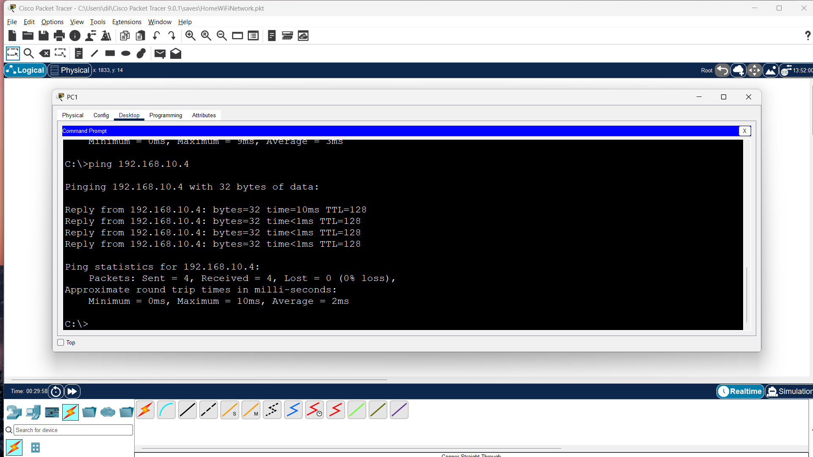
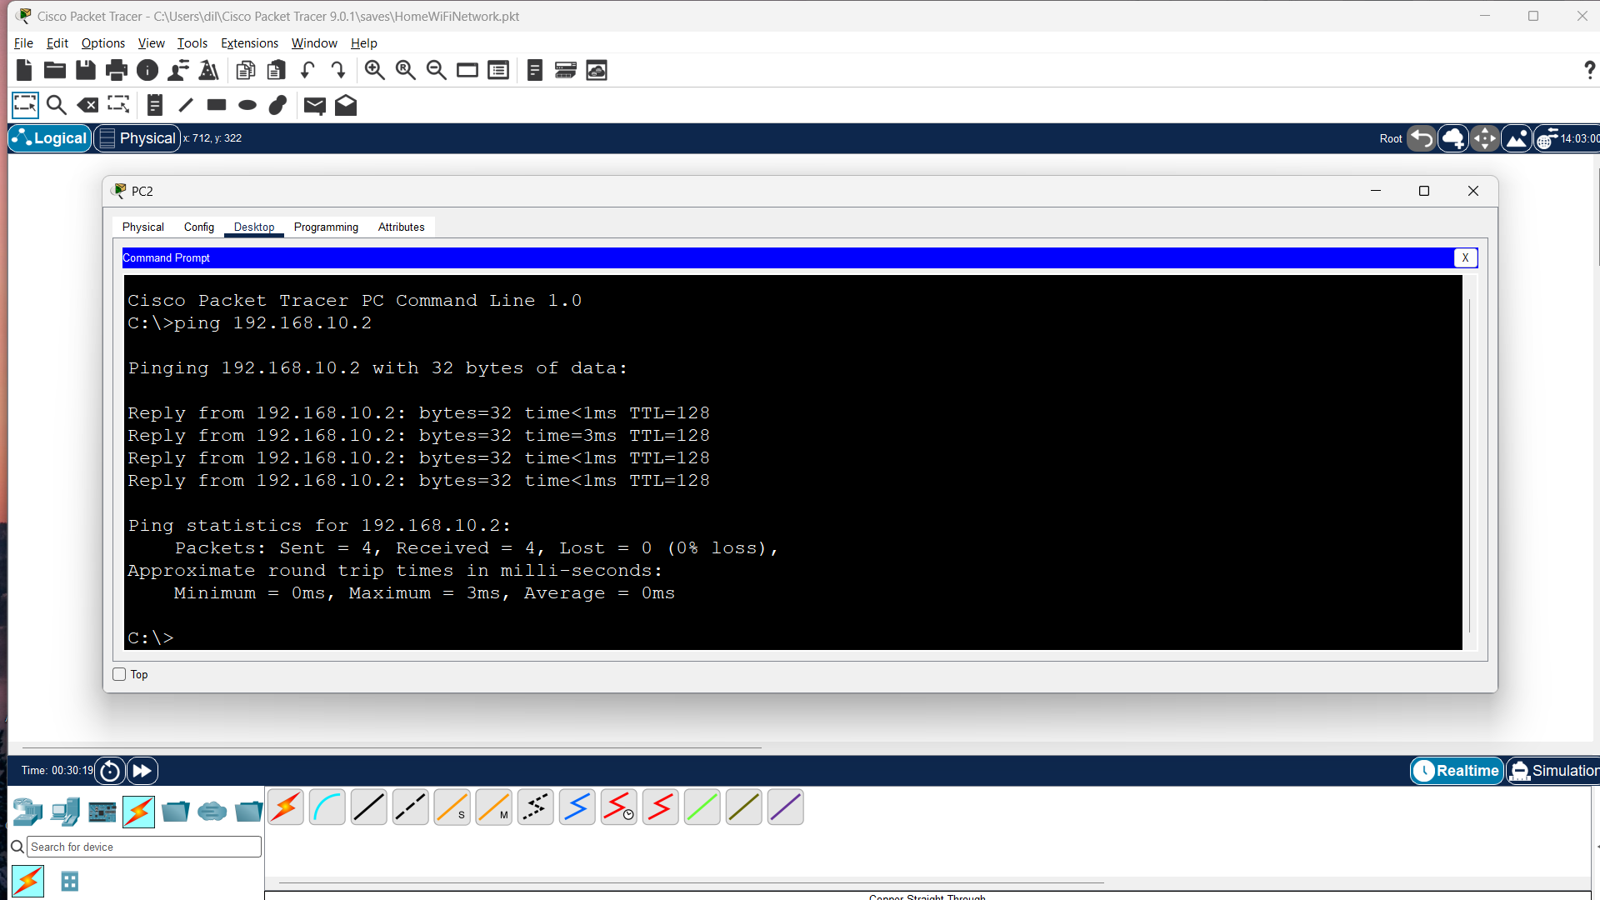
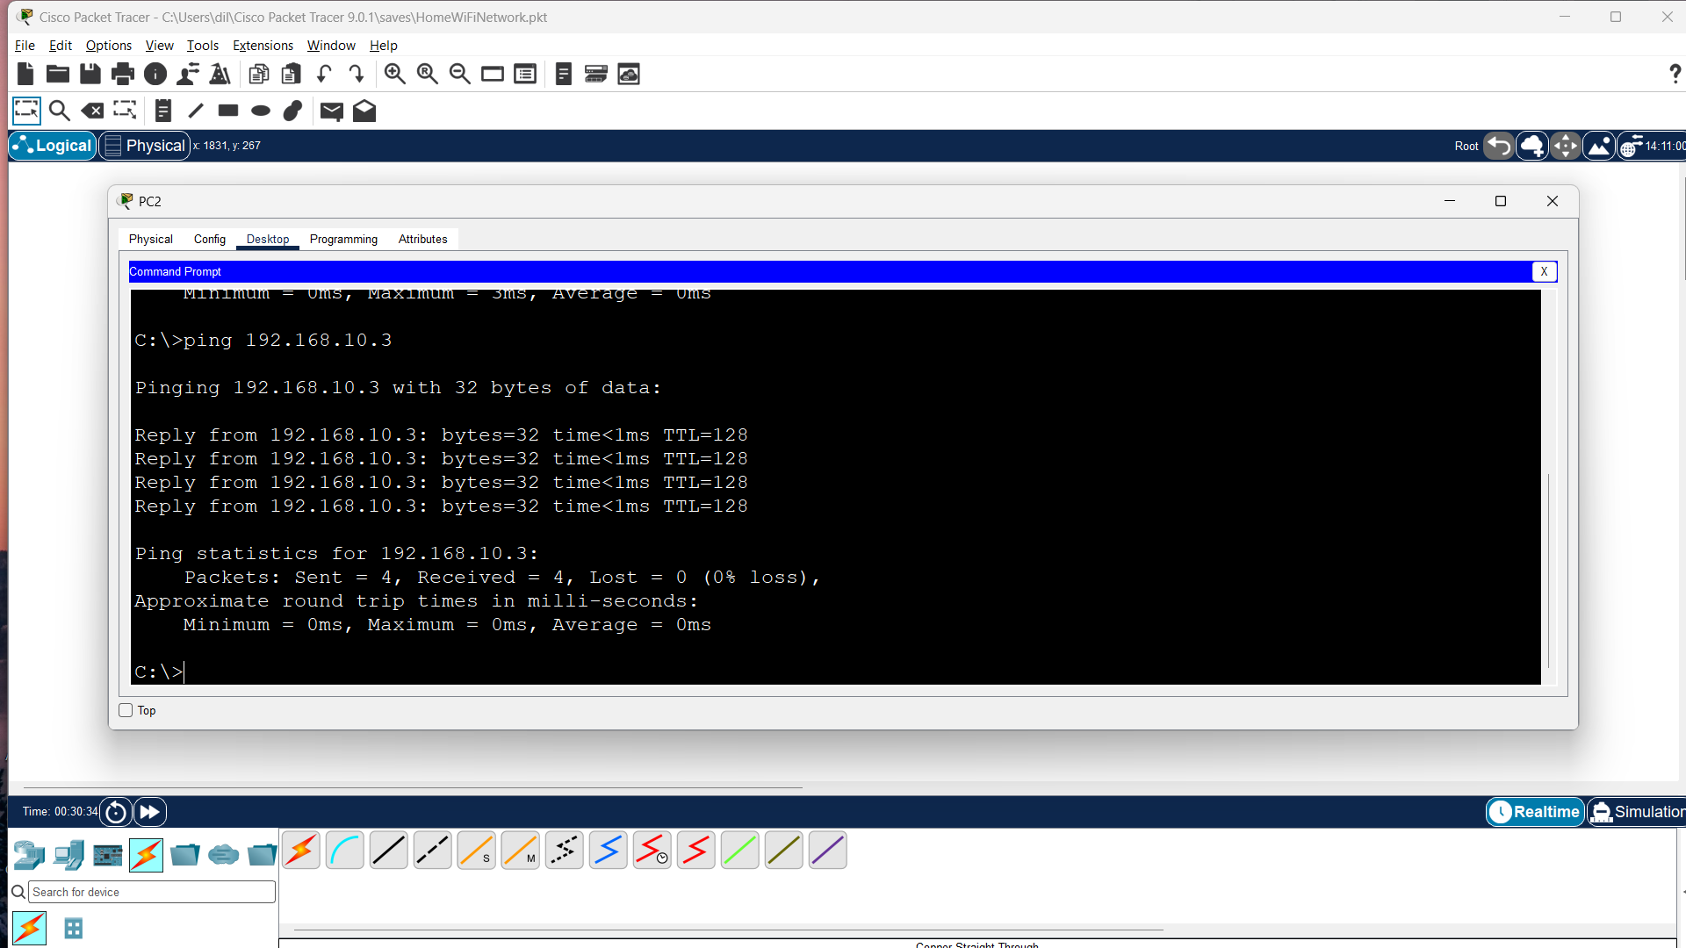
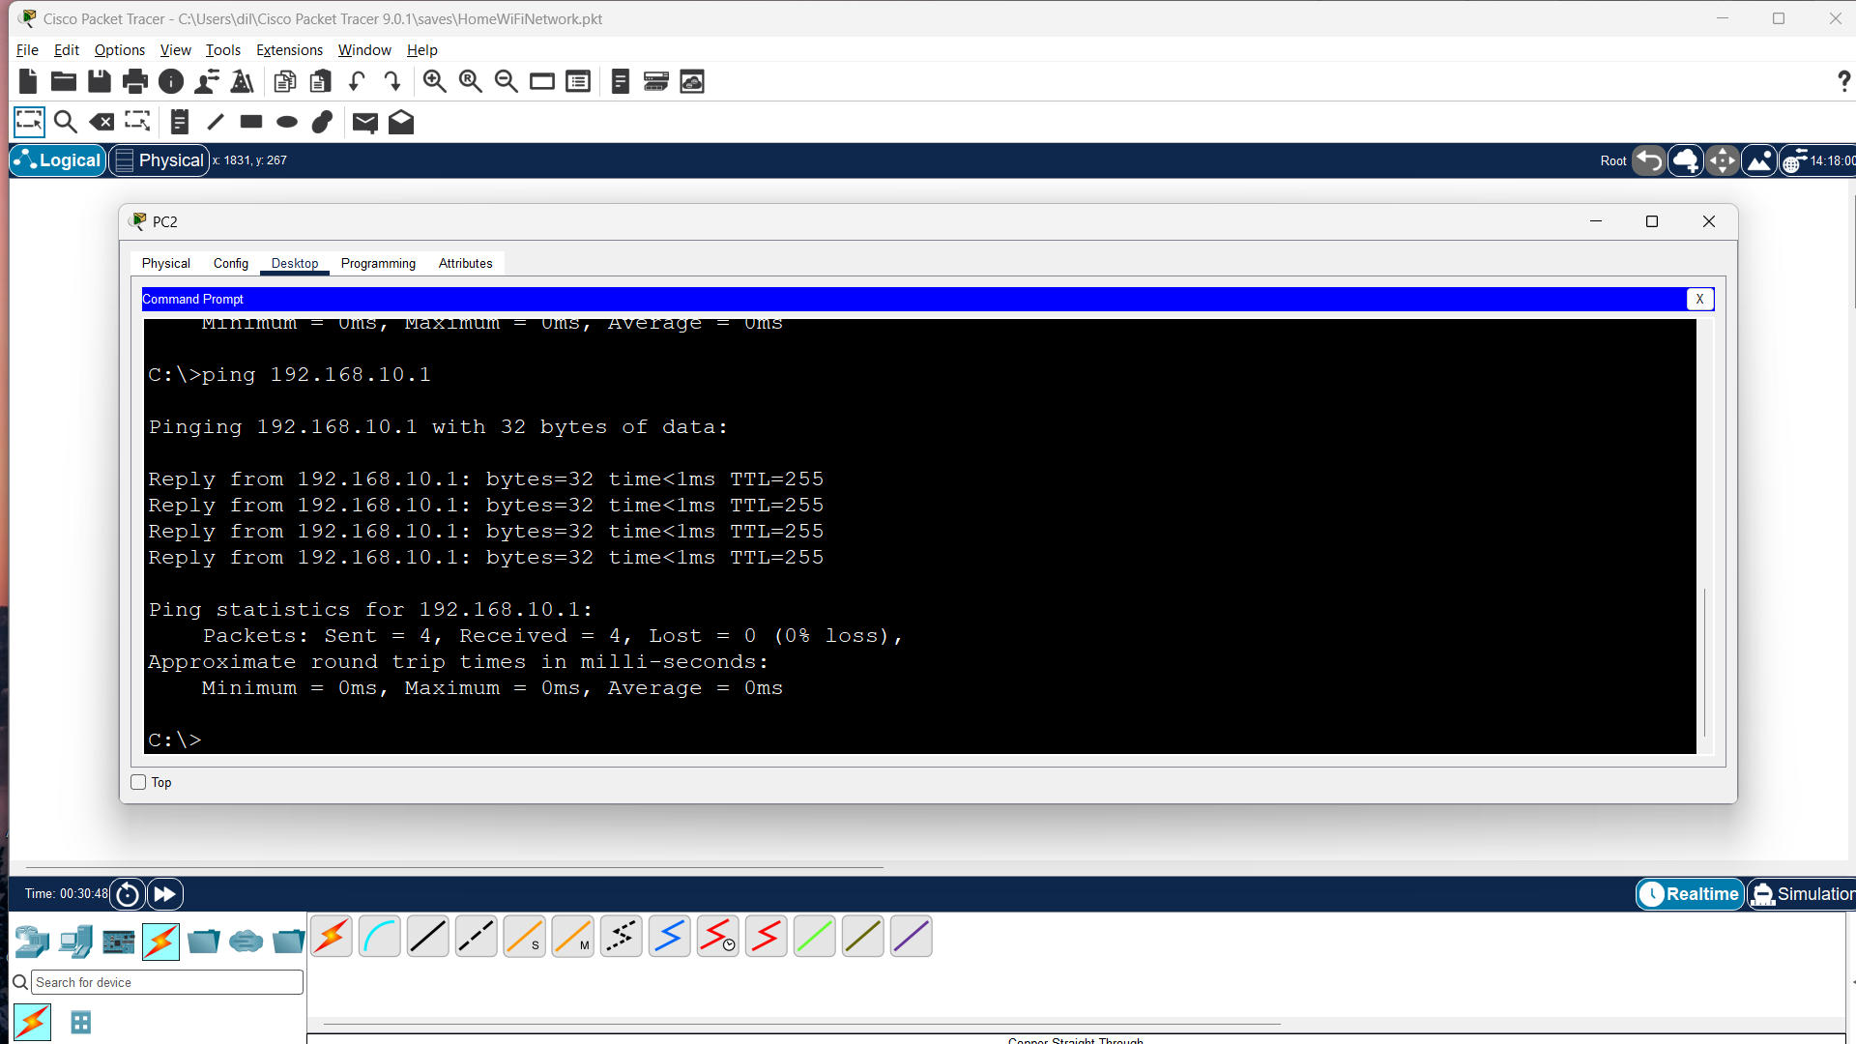
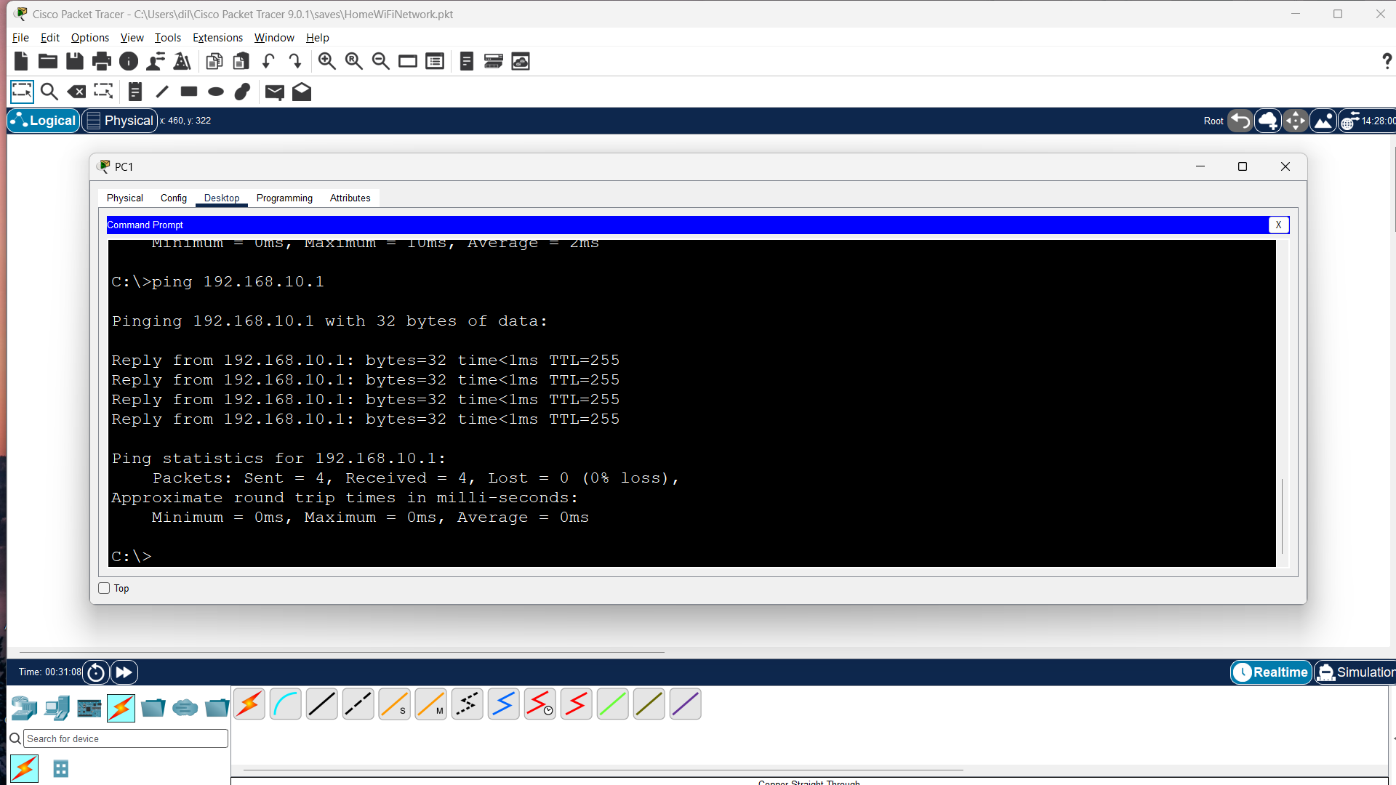
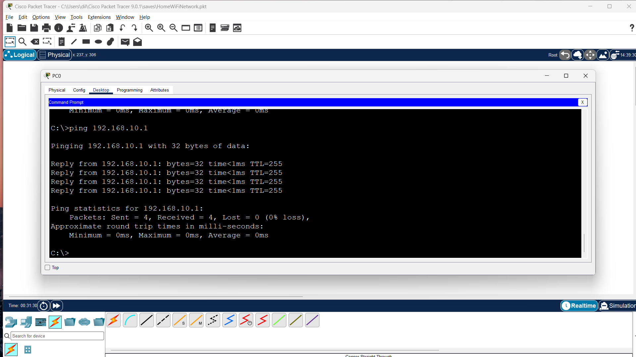

Q4. Documentation of the Network
The network was created in Cisco Packet Tracer using one wireless router and three PCs. The PCs were connected to the router's LAN ports. The router LAN address was configured as 192.168.10.1/24. PC0, PC1, and PC2 were assigned 192.168.10.2, 192.168.10.3, and 192.168.10.4 respectively, all with subnet mask 255.255.255.0 and default gateway 192.168.10.1. Connectivity was verified using the ping command.

Result
The HomeWiFiNetwork.pkt topology was created and configured successfully, and connectivity was tested between the PCs and the router.

Conclusion
This practical demonstrates how to build a small home network, configure static IPv4 addresses and a default gateway, and verify communication using ping.

